- Nebraska is one of the highest in the Untied States and we are ranked 2 for beef.
- Kearney is one of the most beef cow inventory.
- Bull- a bull is a mature male who has never been castrated and is capable of breeding, which is their primary use in a cattle operation. Bulls can be aggressive and are capable of causing injury to any animal or humans they view as a threat.
- Cow- is a full grown female animal. To be considered a cow, you need to be at least a year old to have a calf. A calf is a baby cow. Cows produce meat, milk and breeding
- Steer- a steer is a bull who has been castrated. Typically steers are more docile to handle than bulls. Steers are more often used for meat producing.
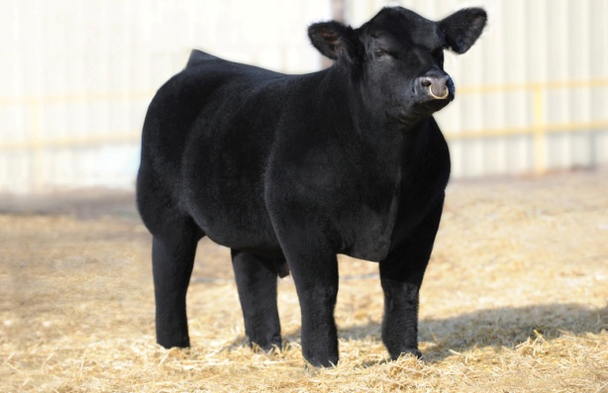
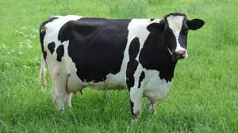
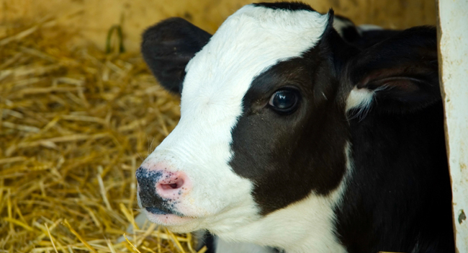
- Heifer- a heifer is the term used to describe a young female, cow, who has not had a calf. Heifers can be breed used foe milk producing or sold for meat. 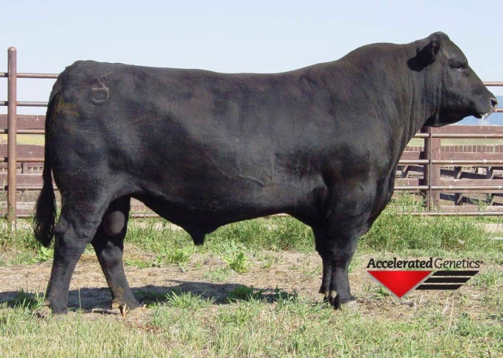
            - By Hope Pickel

