SOME FOOD MADE from wheat graham crackers ,cereal.
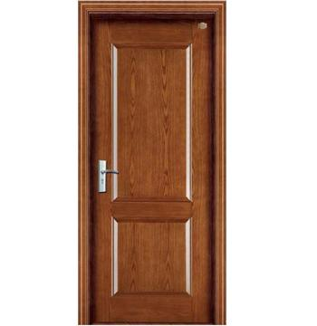
First they harvest the wheat then they check the moisture, then they put it in trucks and it gets to your door like that.
